**Location Finder Service Report**

**Introduction:**

The **Geolocation API** allows the user to provide their location to web applications if they so desire. For privacy reasons, the user is asked for permission to report location information.

In this service, we will use html geolocation API to find out the location coordinates that is latitude and longitude of the user. As geolocation only works on browser , we will be using javascript to automatically store the longitude and latitude coordinates of the user when the location service is selected. These coordinates then will be sent to the server and will be stored there. Geolocation only provides the coordinates of the user , not any other information like country or state. For that we have to perform reverse geolocation , for this we will be using another API that is **bigdatacloud.** It’s a free reverse geolocation API that returns the information like state, country, city etc.

**UML Diagram:**

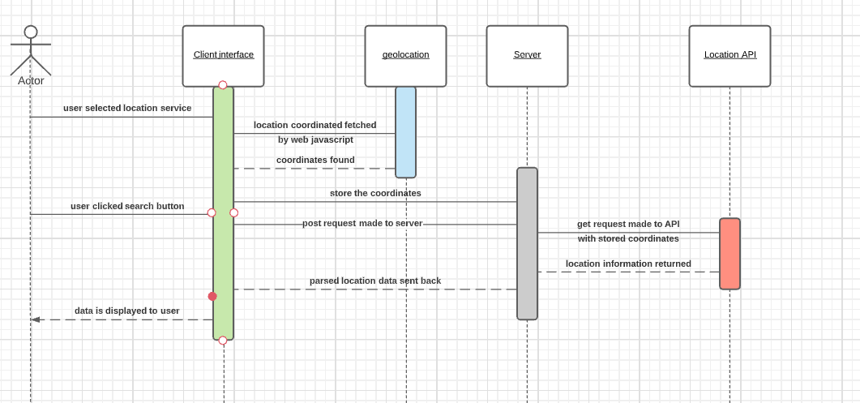

The above diagram represents the sequence diagram of the complete user-server-API interaction. The sequence diagram shows how the data is fetched from the API and parsed and sent back to the client interface which displays this data to the user in a format.

**Client and Server interaction:**

When the user select location service, the web javascript calculate the location coordinates using geolocation API and then sends that coordinates to the server and server stores that coordinates in a variable. When the user click on submit button, it makes an post request to the server which further makes a get request to the location API with the stored coordinates and return a response with the location data. The server on receiving the data, parse it and send it back as response ,which is then rendered on the client interface.

**References:**

<https://developer.mozilla.org/en-US/docs/Web/API/Geolocation_API>